Question 1:-



Output:-

class Node:

def __init__(self, data):

self.data = data

self.next = None

class LinkedList:

def __init__(self):

self.start = None

def Insert(self, value):

newNode = Node(value)

if(self.start == None):

self.start = newNode

return

else:

temp = self.start

while(temp.next != None):

temp = temp.next

temp.next = newNode

def Delete(self):

nodeToDelete = self.start

self.start = self.start.next

nodeToDelete = None

def Print(self):

temp = self.start

i = 1

if(temp != None):

while (temp != None):

print(f"{i}.",temp.data, end = " \t")

i = i + 1

temp = temp.next

else:

print("The list is now empty.")

print()

print()

MyList = LinkedList()

MyList.Insert(10)

MyList.Insert(20)

MyList.Insert(30)

print("Given List: ")

MyList.Print()

print("First Time Deletion: ")

MyList.Delete()

MyList.Print()

print("Second Time Deletion: ")

MyList.Delete()

MyList.Print()

print("Third Time Deletion: ")

MyList.Delete()

MyList.Print()

Output:-

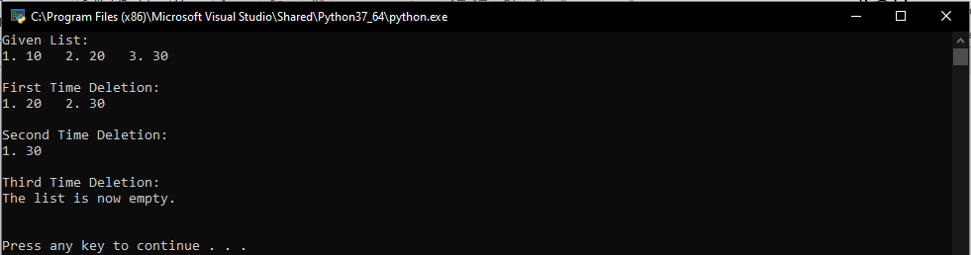

Question 2:-

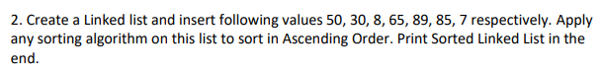

Code:-

class Node:

def __init__(self, data):

self.data = data

self.next = None

class LinkedList:

def __init__(self):

self.start = None

def Insert(self, Value):

newNode = Node(Value)

if(self.start == None):

self.start = newNode

return

else:

temp = self.start

while(temp.next is not None):

temp = temp.next

temp.next = newNode

def Sort(self):

while True:

swapped = 0

temp = self.start

while(temp.next is not None):

num0 = temp.data

num1 = temp.next.data

if(num0 > num1):

temp.data = num1

temp.next.data = num0

swapped = 1

else:

temp = temp.next

if swapped == 0:

break

def Print(self):

temp = self.start

i = 1

if(temp is not None):

while (temp is not None):

print(f"{i}.",temp.data, end = " \t")

i = i + 1

temp = temp.next

print()

print()

MyList = LinkedList()

MyList.Insert(50)

MyList.Insert(30)

MyList.Insert(8)

MyList.Insert(65)

MyList.Insert(89)

MyList.Insert(85)

MyList.Insert(7)

print("Given List: ")

MyList.Print()

print("Your Sorted List is: ")

MyList.Sort()

MyList.Print()

Output:-

